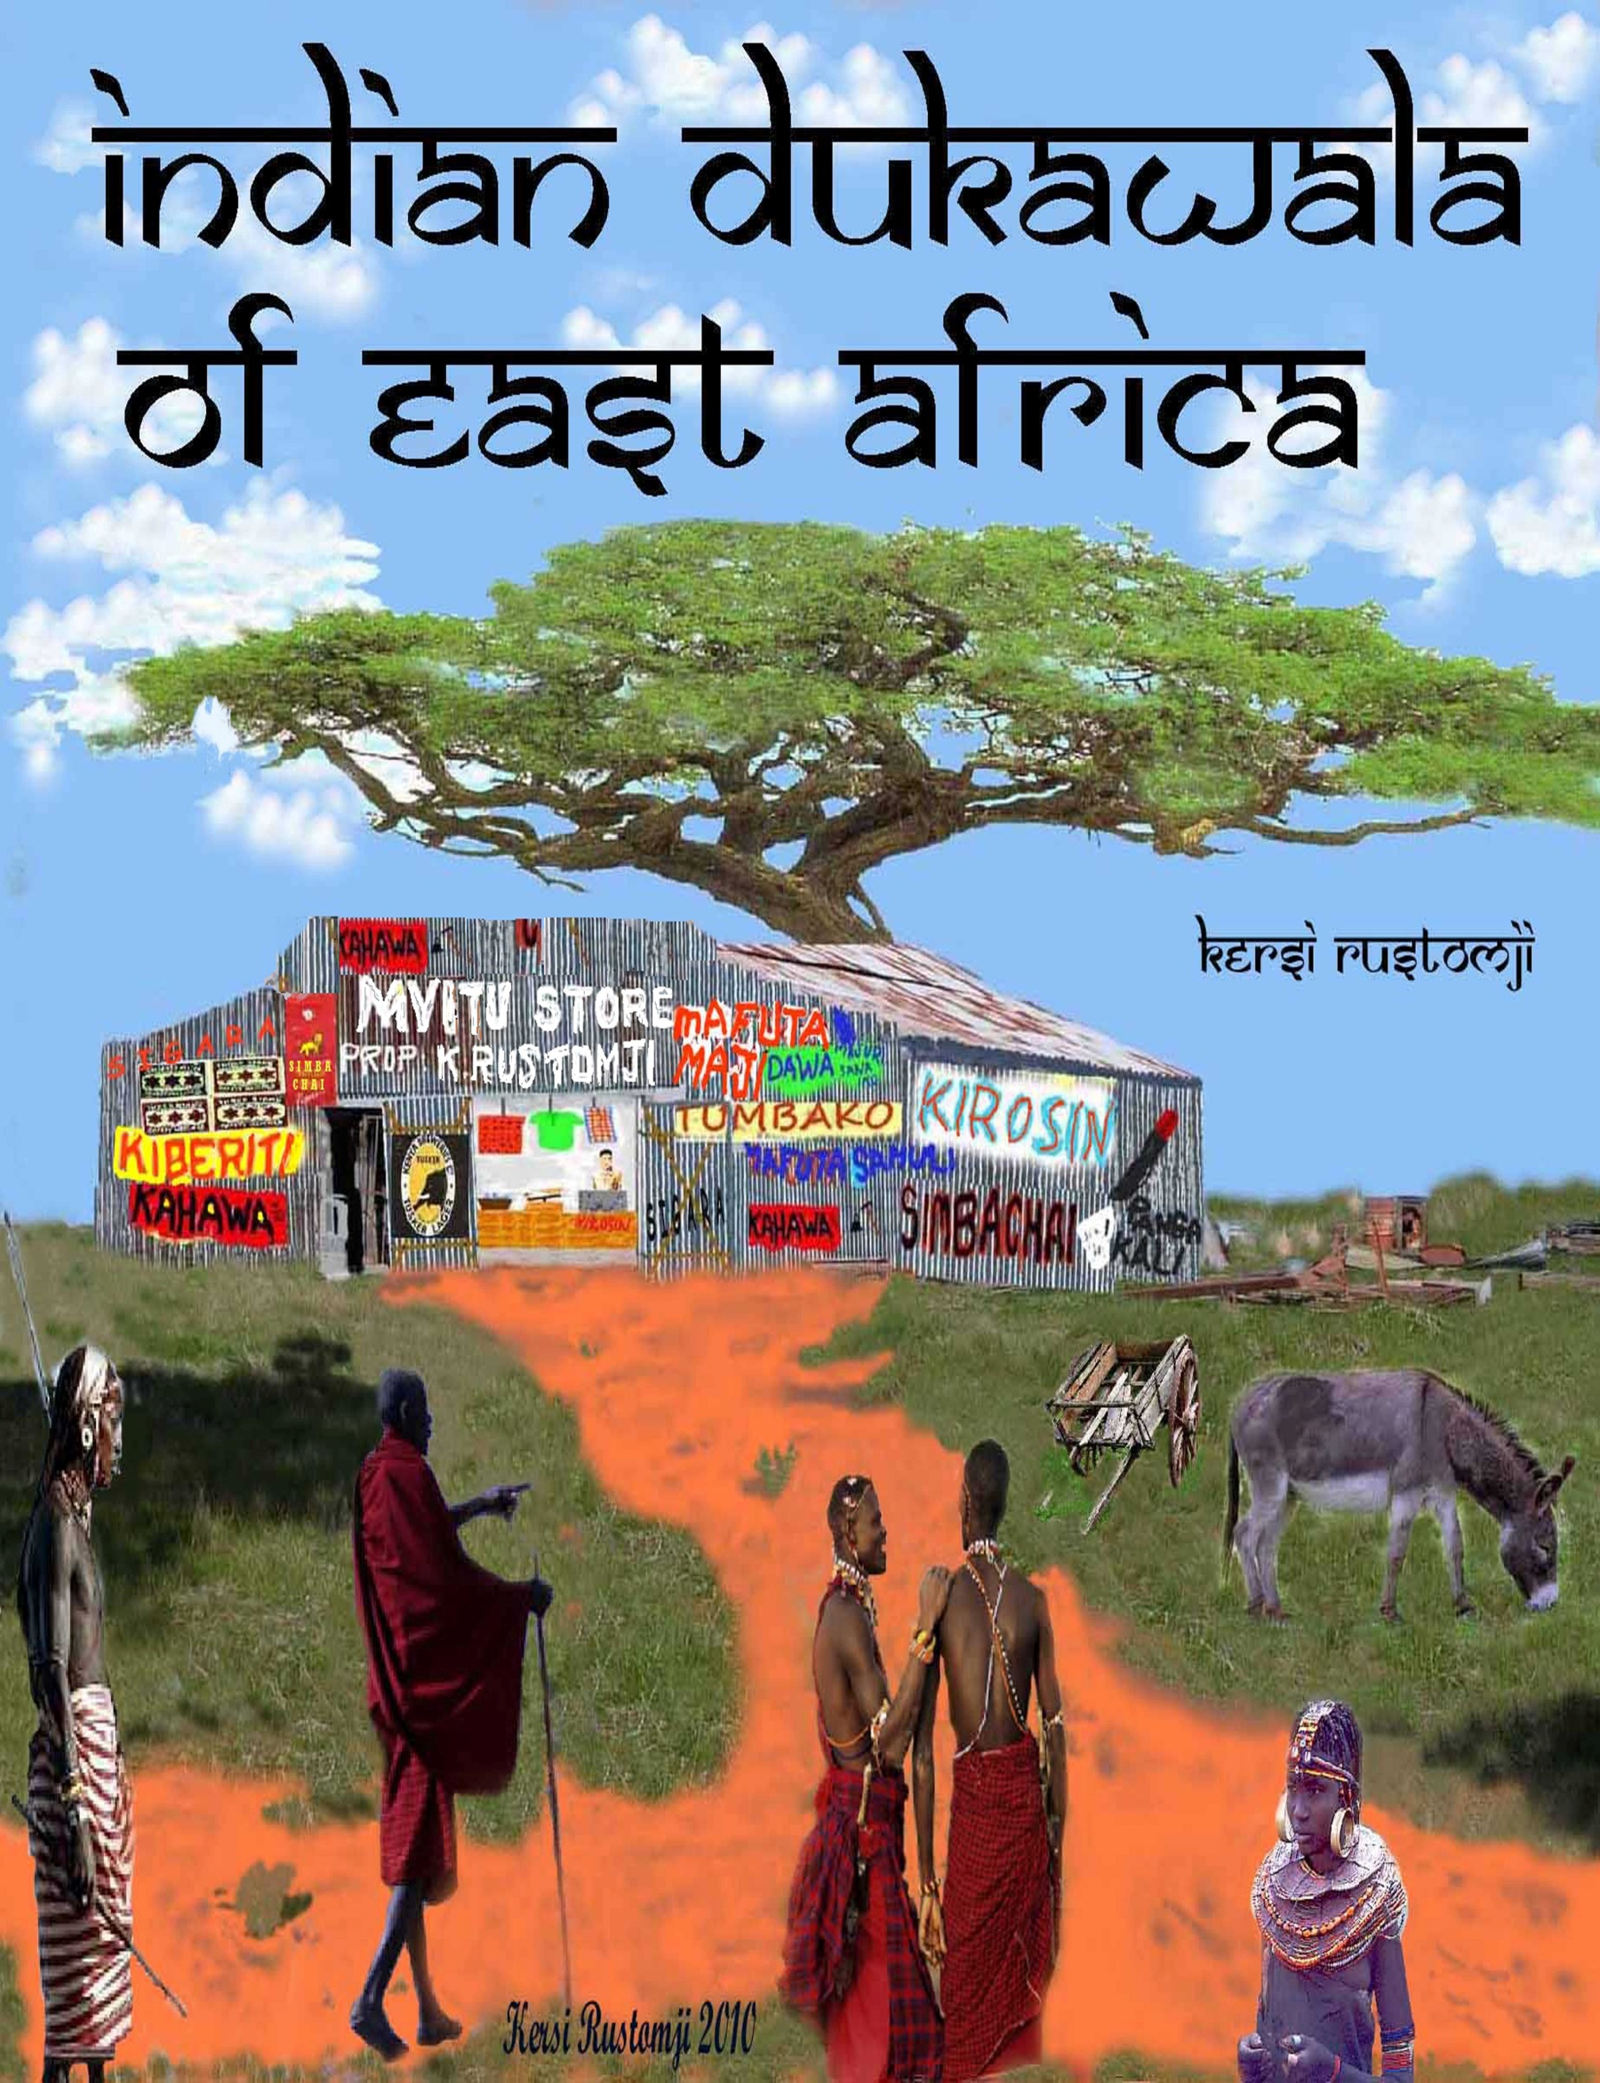

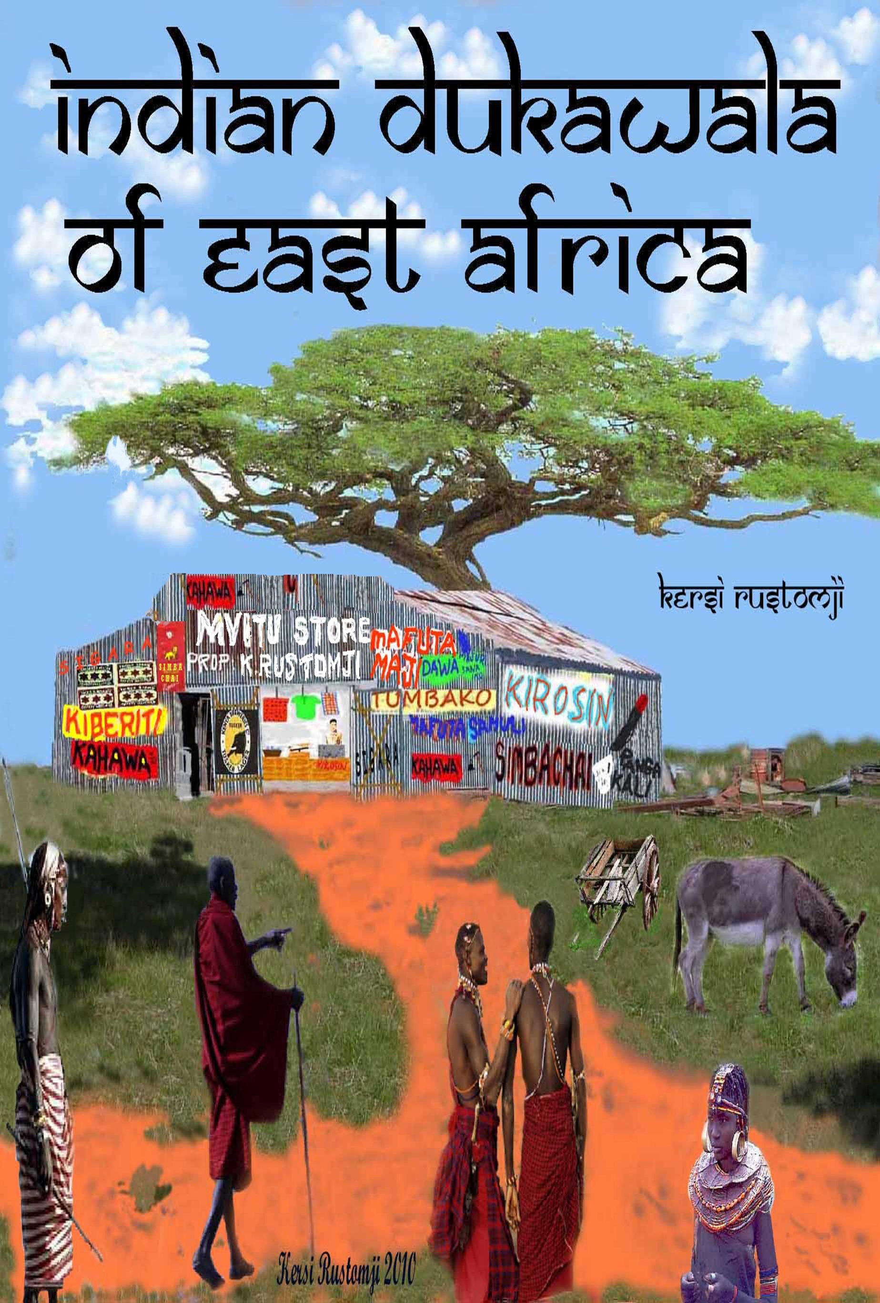

The cover

The cover depicts on the rich red soil, a typical Indian duka, a small trading store, in small towns and remote country areas of East Africa.
The signage is also typically hand painted work of the duka owners. These were put up with any paint at hand, and included some spelling errors.
The man behind the counter is my paternal uncle Jehangirji Rustomji, who first opened a small watch repair duka in the old Indian Bazaar, in early 1906 in Nairobi, Kenya. He later moved to the then Government Road, now Moi Avenue, in the corner of a chemist shop, Chemitex, next to the old Alibhai Sherrif hardware shop, going towards the Khoja Mosque, the Jamat Khana, on the corner of the old Government Road and River Road.
Later his youngest son Rati joined him, and after his death Rati carried on the little business till 2009, when after 103 years service he retired, and closed the little duka. At the time of writing, Rati still lives in Nairobi.
This work is a small tribute to the unsung intrepid pioneering Indian traders, and very often their families, who braved the unknown hazards of the Dark Continent, carried on regardless of ease, comforts, privations, ill health, and even death which they knew was their constant and real possibility.
They have in no small measure played an important role, in the economic growth of the three East African nations of Kenya, Uganda, and Tanzania, hitherto unrecognised nor given a deservedly appropriate place, in the annals of these nations.
Without a record of these traders and other Indians who also played a very prominent and important part in the economic and the political growth of these nations, the histories of these three East African countries would be incomplete.
The cover and the work © of Kersi Rustomj
All graphics unless otherwise indicate © of Kersi Rustomji AUSTRALIA 2012
kersiru@gmail.com

ODE TO THE INDIAN

DUKAWALA

ON

EAST AFRICAN PLAINS
********
Done the Mombasa Kisumu rail,
And of all the Indian rail men,
Many to India in dhows sailed,
But some majur the workers,
And suthar the carpenters,
As well luhar the smithy and tin workers,
Stone masons and builders,
In the country they had laboured,
To commence a life new they remained,

Then soon a fresh and new Indian breed,

Of bold pioneering trading creed,

Sailed in the creaky wooden dhows,

Along with the Indian crows,

If lost at sea to guide them ashore,

Towards ventures new to commence.

Hara Ambe, Hara Ambe,
An Indian dukawala,
On the East African plains
Braving malaria black water sleeping sickness,
Diseases fevers many and unknown ills,
Undeterred by lions leopards and snakes,
By hyenas owls bats and other nightly beasts,

Nor afraid were they of the mysterious mchawi,
The lion skin wearing native magic man witch,
To strive and to pave a new way and life to be had,
Into Kenya Uganda Tanganyika then far inland they also spread,

Through scrubby lands jungles arid terrain,
Many wide rivers and muddy streams crossed they,
Where mosquitoes tse tse flies bugs and vermin,
Infested bodies and their blood sucked,
Caused many ill health and fevers to be had,
Made not a few along their routes to fall dead,

On one hot sunny sultry African morn,
Such an Indian on foot he trekked,
To seek a little plot in the land so hostile and strange,
On the vast sprawling warm savannah plains,
Among grasses yellow and flat topped thorn trees,
Near a brown barked flat topped acacia green,
Just the right patch of empty red earth saw he,
‘Perfect for a small duka,’ a tiny little store said he.

Hara Ambe, Hara Ambe,
An Indian dukawala,
On the East African plains

From the hard dry red ground the duka it was raised,
The skin robed and spear totting locals gathered and watched,
As the duka rose it they languidly appraised,
Hammer blows on the plain loudly thudded,
As sides and top of mabati the iron corrugated,
Onto a wooden frame with myriad nails attached,

Now in the mvitu of the stark wilderness,
A small mabati duka a shop in the front,
With a couple of tiny rooms in the back,
Of the Indian dukawala’s a new tiny abode it became,
In front a place from which to work and trade,
Then in the dark starry and chirpy African night,
To lay his tired body in a rear room to bed.
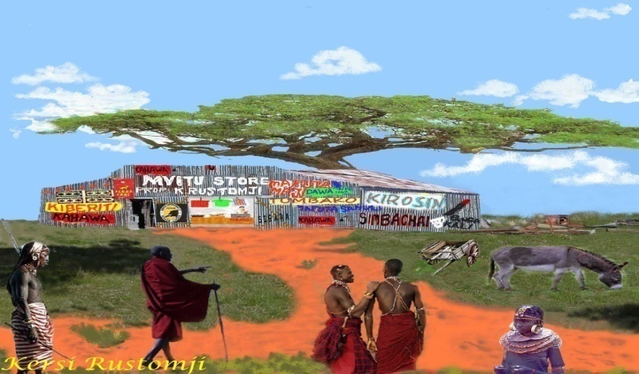

Hara Ambe, Hara Ambe,
An Indian dukawala,
On the East African plains

Watu, the bush people with the dogs pied,
To this strange mabati box they soon arrived,
Viewed the unknown iron sheet kibanda,
A novel structure so maridadi wonderous,
Full of curiosity first with trepidation then cautiously,
They entered the duka somewhat nervously,
To scan see feel to taste and try,
The many new goods foods tools and wares,
That they had never before seen,

New cloths and clothes knives nail implements and tins,

Sukari sugar groundnuts salt pulses and grains,
Unga the ground maize dengu the daal,
Rice legumes and a variety of lentils,
Pili pili the hot dried chilli binzari various spices,
Dried ground ginger the sharp tangawizi,
Pili pili manga, strongly pungent yellow turmeric,
Also the round black pepper berries,
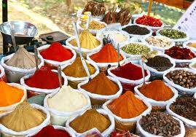Now to add to new foods and to make delicious curries,

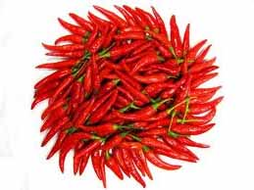

Tumbaku the dark rolled tobacco,
To smoke in novel pipes the kiko,
And the dark brown scented snuff fine the ugolo,
In fancy snuff-boxes the tiny tabakelo,
Amazing to wash with Indian sabu sabuni the soap,
As well sigara cigarettes in packets or ready rolled,

And small hand mirrors for one’s face to look at,
For their belles and their many wives they saw,

Colourful beads baubles combs pretty,

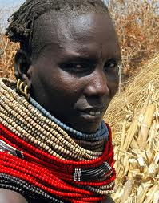To decorate their arms and necks with,

Metal coloured enamel and china containers held them all in awe,
Msusimeno the saw and iron axes for wood to easily chop,
Wire for binders and long choir ropes,
Wire mesh for chicken coops strong.

Hara Ambe, Hara Ambe,
An Indian dukawala,
On the East African plains

The dukawala too from the locals,
Many needy things he required,
Milk honey skins and hides,
From them all he regularly acquired,
Makka the charcoal to cook with,
Mswaki the acacia tooth brush stick,
Many other local produce and products,
And different local stuff he bought,
Paid for it in the tinkling rupiahs shiny,
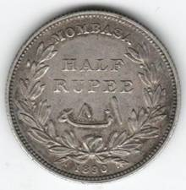Brought to the country by the new white government serikali,
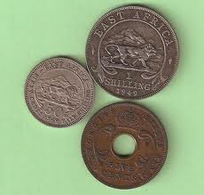Then replaced by centi cents and shilingi shilling,

Year by year and on and on,

The little duka it did so very well,
Glassware jars pots and pans,
Even an odd iron frying pan,
From long nails in the rafter beams hanged,
Needles buttons and coloured threads,
Scissors razor blades machete the panga and spades,
Bata shoes in leather and canvas,
White Merikani the tough woven cotton cloth,
Kitenge wraps and various pattered and coloured cotton bolts,
By yard were there for all to be had,
Also coloured bead necklaces and even metal bangles,
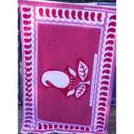For all the wanawake the women to wear,

With magic kiberiti the box of matches,
And amazing mafuta maji the clear kerosene,
Mshumaa candles and hurricane lanterns with cotton wicks,
In hundreds of rustic grass huts were now nightly lit,
As well in the dark African night,
Amid the thick bushes and thorny trees,
The narrow earthen bush tracks and paths,
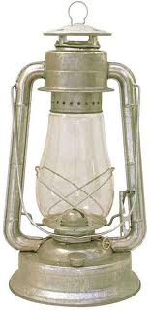 The hand held lamps lighted.

Hara Ambe, Hara Ambe,
An Indian dukawala,
On the East African plains

A Mafuta new superfine oil and samli ghee,
Gave a flavour new and different tasting,
So very rich so very food enhancing,
And very different from the boring,
The old boiling way of cooking,
As roti the Indian flat chapatti,
Fresh piping hot smeared with ghee,
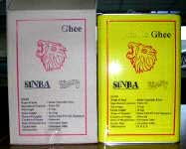Now replaced the old morning maize meal the uji,

For the ills and sicknesses of past and existing,

There were also now treatments new,
That came with the many new dawa the remedies,
From India and white man’s patent medicine,
For the churning maradhi ya tumbo,
The crooked worm ridden tummy,
There was the yellow castor oil,
The foulest of all and smelly,
Not at all the tiniest bit yummy,

None was there other bitterest than any,
The yellowish malaria curing quinine,
For cuts bruises and lacerations,
A burning liquid in a dark glass bottle tiny,
The brown sharp smelling tincture of iodine,
For the muscles stretched aching and tired limbs,
The moustachioed Sloan’s yellow liniment,
Or the Indian Amrutanjan balm,
On the hurting aching parts to rub in,
As well Indian medicinal oils and salves,
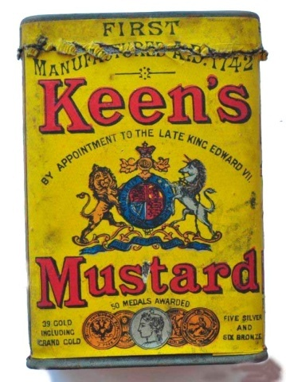Or cotton cloth plasters of mustard or turmeric.
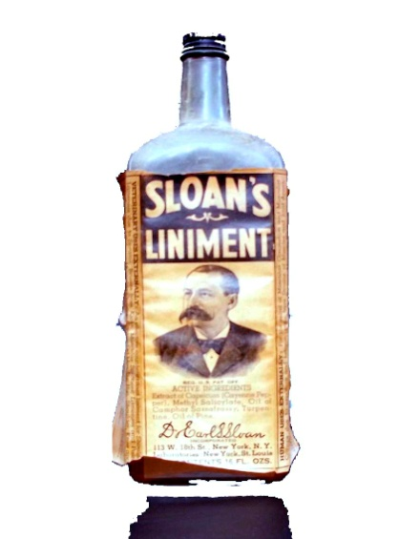

Hara Ambe, Hara Ambe,
An Indian dukawala,
On the East African plains

The new aluminium saucepan sufuria,
As well the three legged cast iron pots,

And other such metal utensils,

Of the olden pots and the ancient wares,
Crafted from hollowed gourd wood and earth,
The final end brought these,
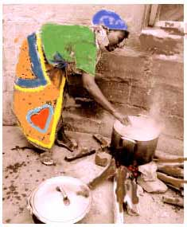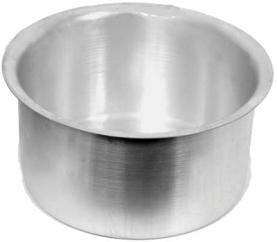Changed in bush and huts old cooking habits,

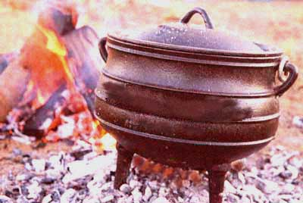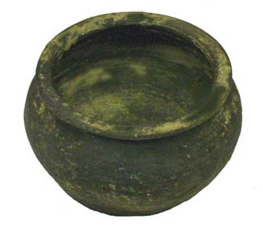

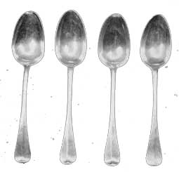The shiny small and big kijiko,
The gleaming metal spoons,
To stir and eat with into use daily,
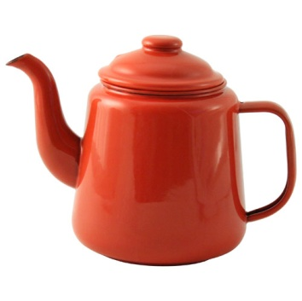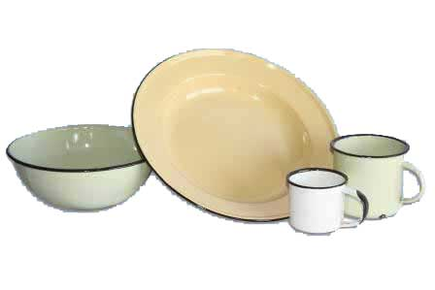Came so very quickly and so very early,

For the enamel tea pots birika,
And the colourful kikombe the mugs,
As well the many coloured enamel plates the sahani,
Of the old eating boards and banana leaf platters,
And the half cut drinking coconut shells and gourds,
It all brought demise rapid,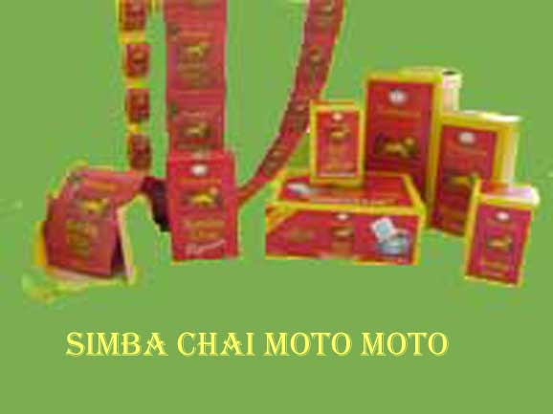
For now coffee the kahawa or chai the tea,
Has become a morning ritual new,
A daily invigorating treat,
With a wheaten ghee smeared chapatti or two.

Hara Ambe, Hara Ambe,
An Indian dukawala,
On the East African plains
The red blue and yellow designed sinia the large enamel platters,
Now in huts shambas farming plots and soko the markets,
Wanawake ya soko the market women and hawkers in street,
On colourfully scarf covered heads they bear,
With their loud cries of korosho kashew and tende dates,
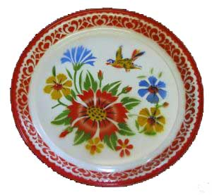Their various wares and produce they vend,

Impala and other skins also were soon discarded,
For cotton shukas and kitenges as wraps,
Of designs and patterns in brilliant colours variegated,
With limerick or a verse at the bottom hems,
Naku penda malaika yangu,
Love you my angle,
The attire new by all women now adopted,

Even the Masai the Samburu and the Turkana men of the plains,
On the nyika and everywhere else,
Their skin cloaks of old divested,
A fashion bold and new adopted,
A knotted drape of a red blanketi,
Bought for mere rupia mbili,
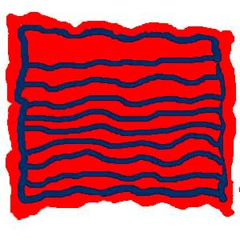At the small Indian shop duka ya mhindi.

But the mode of dress for many more across the countries,

Once more again the attire changed,
Another fashion of apparel new now accepted,
Shati sleeved shirt and pants the seruali,
Almost all men in the land started wearing,
And mamas the women too,
Their worn ochre robes and string skirts of past,
They replaced with colourful nguo nzuri ,
Pretty cotton drapes and dresses.

Hara Ambe, Hara Ambe,
An Indian dukawala,
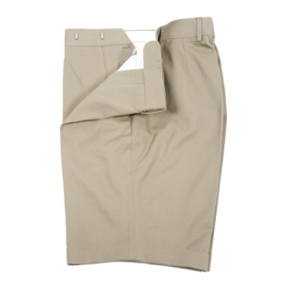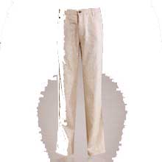On the East African plains

The old hard dry digging sticks of yore,
These too were of use not anymore,
Its place now taken by grey jembe,
The new strong iron hoe,
The new jembe a tool of metal strong,
Together with panga the metal machete,
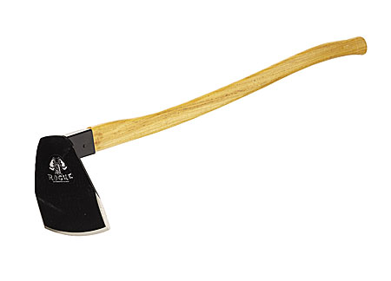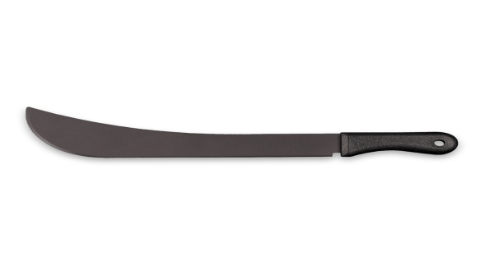Changes on the landscape wide it wrought,
With ardhi the soil now easily dug turned and aired,
Big shambas over the land not before long stretched,
From early morn to till late in the day,
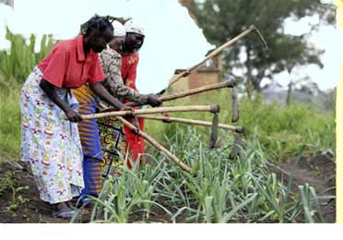Long and wide toiled mke the wives and women the mwanamke,

For bigger cash crops to sow and raise,
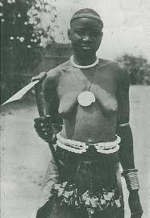Seeds from the Indian duka they bought and planted,
Lentils mung pulses and other beans,
The large cob bearing tufted mahindi,
Then soon potato cabbage and peas,
Coffee cotton millet they soon raised,
Tomato onion garlic and chillies,
Beetroot lettuce and radish,
Karela bitter gourd and mbiringani brinjal,
Carrots cauliflower spinach green,
Fresh green coriander, kakari cucumber,
figili, pungent white horseradish,
On their shamba plots they established,
For the many wahindi the Indians, and the wazungu the whites,
Who now in the three countries resided.

Hara Ambe, Hara Ambe,
An Indian dukawala,
On the East African plains

The trade at the little rusted mabati duka,
It prospered and did so very well,
The myriad goods spread on the counter,
Along with boxes of produce and grains,
In the midst of all a weighing scale,
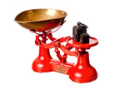To weigh it all in pounds or ratli,

Beside on the floor in front of the counter,
Sat tins of ghee cooking oil and kerosene,
Ladled out with a long handle tiny scoops,
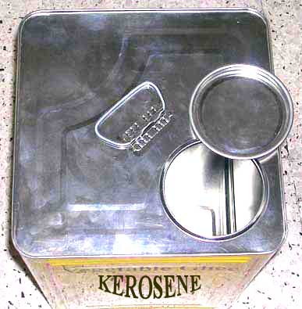At only senti tano five cents each,

Varied coloured cloths and clothes,
From the roof beams hung,
All in hot dusty winds gently swung,
Just above wall shelves thickly loaded and stacked,
An accumulation of large and small commodities rested,

The long time Indian dukawala of old,
On many new deals and ventures big embarked,
Still filled with vitality vigour and pep,
He forged ahead in great big striding steps,
From the locals all and surrounds wide he bought,
Their labour produce and products,
In greater and larger and heavier lots,
And the donkey cart that hauled goods sundry,
Now in its place a big load carrying lorry.

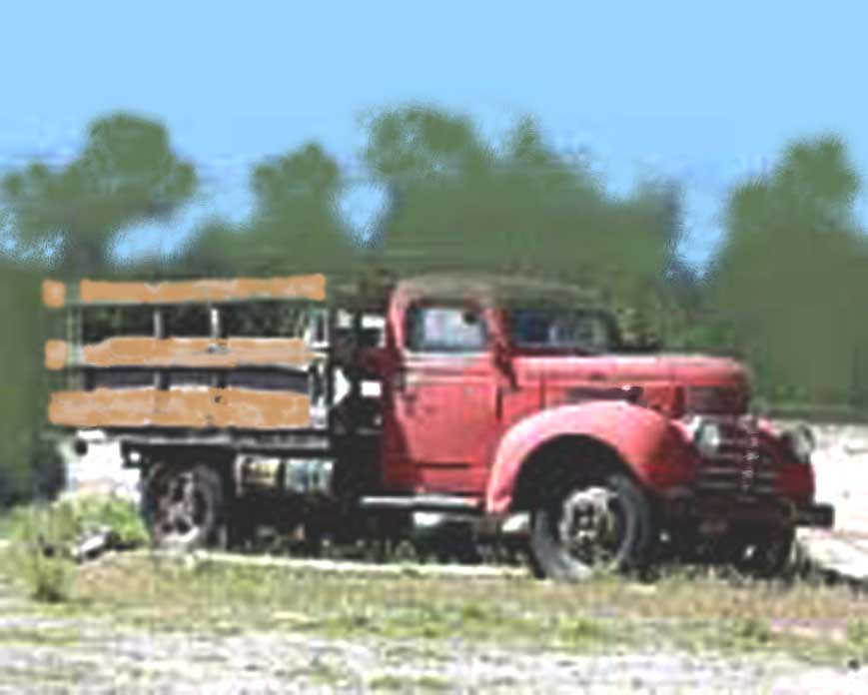

Not long after the mzungu P C* and the D C,*
In the loaded OHMS* lorries rolled in,
Built their bomas offices and bungalows,
Also for the men of the government the serikali,
Followed by the farmers and settlers white,
And not unlike the pioneer Indian dukawala,
With the same silvery corrugated mabati tin,
Their early farmhouses and homes they all also built,
Even the first National Bank of India in Nairobi was of such mabati,
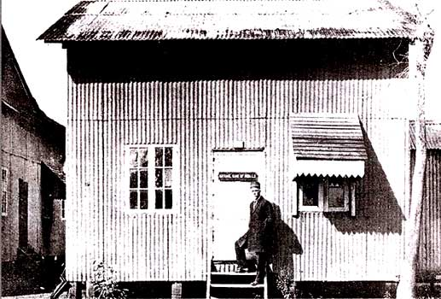Manned by a pheta wearing Mr. Mehta a Parsi.

Now the white farmers with tinga tinga their tractors,
Vast farms and tracts they cut and cleared,
They ploughed and furrowed acres and acres,
On the grass plains of fertile soil red and rich,
Wheat maize oat and other crops they established.

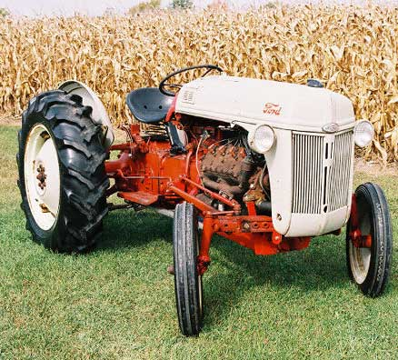

Hara Ambe, Hara Ambe,
An Indian dukawala,
On the East African plains

For the new white farmers and officials,
And other whites who now in three countries resided,
The Indian dukawala to them all supplies provided,
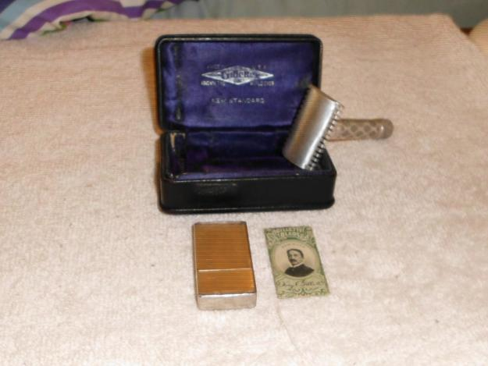Yardley shaving stick Gillette shaving kits and blades,

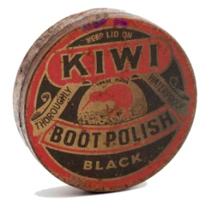

Kiwi boot polish shining cloth with brushes,
Lux and Lifebuoy soap cotton towels and napkins,
Kolynos toothpaste tooth and hair brushes,
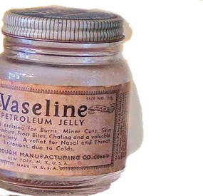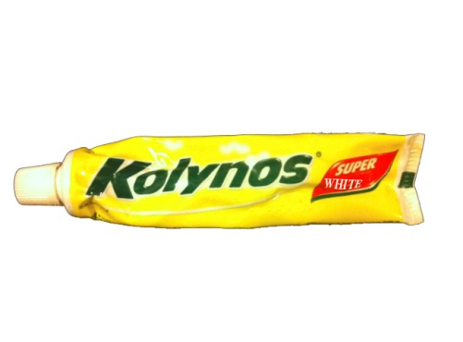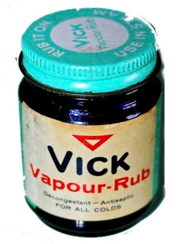Vicks for colds and Vaseline for chaffed skin,

Haig whiskey tobacco cigarettes and Gilby’s gin,
Dry and tinned hard rations,
Butter jams and English pickles,
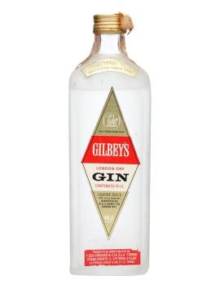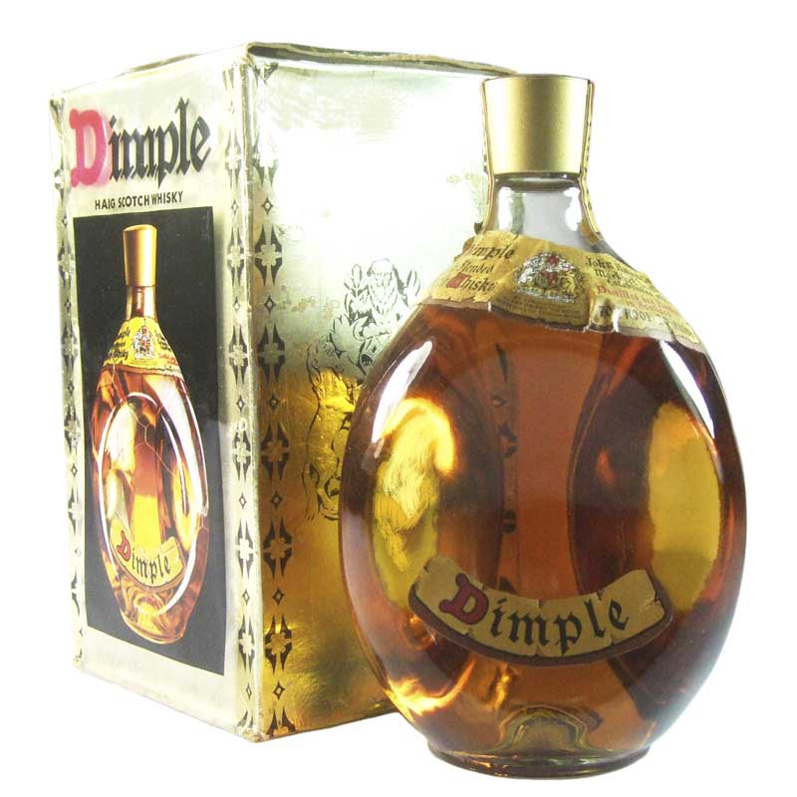Huntley and Palmers biscuits,

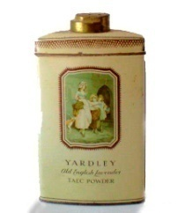Memsahib’s Yardley powder lipsticks and Ponds cold skin cream,
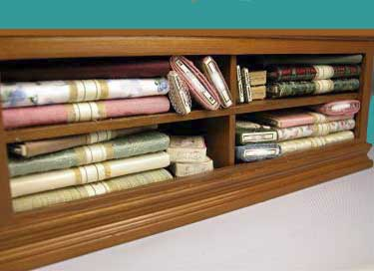Under the counter a variety of printed cotton bolts for their dresses.

Hara Ambe, Hara Ambe,
An Indian dukawala,
On the East African plains

But the wazungu farmers their families and friends,
As well all their bibis the wives,
And all the bwanas the officers of government the serikali,
For reasons not very sure but known to them only,
Disliked derided and mistreated the dukawala most unfairly,

He cheats and overcharges claimed they,
And his business account he writes yearly,
In a language ungrasped and systems weirdly,
Difficult to comprehend easily,
For the white taxman to assess clearly,

In vain manner such white bwanas men and bibis women,
Cursed gossiped and denigrated the dukawala constantly,
Even as one arrogant white farmer lord,
Called him a sucking Asia tick,
In one East African Legislative Council.

Yet when life times and seasons turned hard and mean,
And even the white man banks became unfriendly,
It was on the nastily gossiped dukawala Indians,
For their needs fads and even ready cash,
They leaned at such times heavily.

Yet the Indian dukawala to them provided all their needs,
On a risky unknown chancy surety,
Written on a flimsy unguaranteed paper pieces,
The ubiquitous and hastily signed,
The bwana wazungu’s the white man’s notes,
The many I O Us, and chithies the chits,

Irrespective of ugly taunts and jibes,
Without anger resentment or hate,
The sahibs and their wives supplied he,
With all their fancy needs whims and cash ready.

Hara Ambe, Hara Ambe,
An Indian dukawala,
On the East African plains

The tiny scattered villages into towns grew,
And the towns into cities changed and bloomed,
And now for the inadequate little duka,
Its ripping tearing ignoble end loomed,
As the hammer claws thousands of nails,
With high piercing screech it pulled,

Dusty mabati sheets from the timber frame felled,
The small old duka on its spot no more dwelled,
In the old duka’s space now a swank shopping mall,
Broad sweeping and many storeys glassed plaza tall,
On the roof a neon sign wide and tall,
Another bearing his name high above the glassed wall,

Now the mall is the pride of everyone and all,
From distances great they come to it to behold,
In the new air-conditioned comfort to sit,
The sapping African heat to beat,
Crowds come to stroll to buy or just to see,
To drink a long cold beer with freshly fried samosas to eat,
With its cool cafes restaurants and stores,
In speciality boutiques and shopping malls,
There was none other like it so new,
So cool clean and so very neat,
To beat this rustic dukawala muhindi’s,
New venture a modern business feat.

Hara Ambe, Hara Ambe,
An Indian dukawala,,
On the East African plains

The Indian dukawala though stopped not where he now was,
For on and on he went to build greater enterprises,
Arcades karkhana workshops and factories,
To make fabricated goods products and fineries,
Now needed ever more and more,
In the fast growing East African countries,

Unlike the little mabati shop of days gone,
That now stood no more a part of old history,
For now high from the roofline of many storeys,
The coloured neon signs winked,
Day and night these proclaimed,
Goods and products all now made locally.

Hara Ambe, Hara Ambe,
An Indian dukawala,
On the East African plains

The long forgotten Hara Ambe, Hara Ambe,
The Indian railway builders’ working chant,
To spur them on to shift to carry loads heavy,
Now it became ‘Harambee, hei, Harambee hei,’
A working chant of the local hamali the cart men,
Pushers of laden handcarts heavy,
And the high loaded two wheeled cart the mkokoteni,
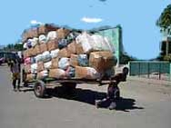

The front man steering ‘Harambee’ he cried,

His pushing mate at the rear ‘Hei’ he replied,

As their heavily loaded carts they wheeled,

Years passed the colonies now desired to be free,
Seeking fighting for nations new to be,
From fetters of colonial white man to be unchained,
‘Harambee’ ‘Harambee’ one of the their leaders hailed,
‘Hei, hei’ his faithful multitude loudly replied,
Of a nation rich and thriving on the East African plains,
A nation of high yellow swaying savannah grasses,
With scattered green flat topped acacia trees,
Of thousands the rallying cry it now became,
‘Harambee Harambee’ their leader loudly shouted,
‘Hei hei’ wanainchi the struggling people responded,

Through severe trials tribulation and deprivation,

And even though their leader was incarcerated,

At a faraway place desolate and isolated,
The country’s freedom the people demanded,

Then as one glorious African day started,

Thousands of his people around him they gathered,
A new flag bright on a high silvery mast unfurled,
With that uhuru the country’s liberation,
Of the one East African nation of Kenya started,

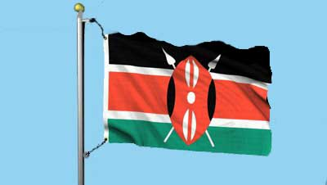

And the hard working peoples of a nation now free,
‘Harambee’ to pull together and spur on they chanted,
As the national motto for all it was finally adopted.

Hara Ambe, Hara Ambe,
An Indian dukawala,
On the East African plains

The pioneering dukawala Indian he is not young any more,
His work and efforts taken over by children now grown,
Gone his very busy days of old and complicated new role,
Hair in a white fringe surrounds the head bald,

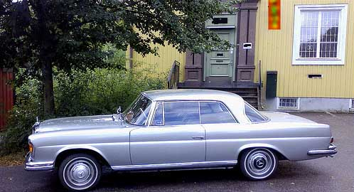In a silver coloured Mercedes that sits before his modern home,

He drives past and observes all that he owns,

For deep within him fully well he knows,
When the time as it surely comes,
Alone bereft and empty handed he goes,

Learned and read of two books only,
With schooling of only years four,
Only to read and numbers to note he knows,
Able not to write at length all,
Seeks he now a learned scribe,
Who in many words will describe,
The many tales of his hard long work life and slog,
Of his visions and of a great trading lore,
Of at least one Indian dukawala on East Africa’s dusty floor,

For unlike the forgotten Indian railway men,
He yearns to leave behind at least a name,
Of the Indian trading pioneers intrepid,
Who to East Africa in dhows came,
Of the tiny mabati duka fame.

Hara Ambe, Hara Ambe,
An Indian dukawala,
On the East African plains

prema, shanti, ahinsa...
upendo, raha, latifu...
love, peace, kindness...
Only One Human Race...

********

Kersi Rustomji. Planet Earth. Ex-Kenya. Australia.

Copyright: Kersi Rustomji, 2012.

kersiru@gmail.com

* P.C. and D.C. After the Governor of the colony, P.C., the Provincial Commissioner was in charge of a large province of the country, and D.C., the District Commissioner in charge of a smaller district of the provinces.

*OHMS, all East African the government vehicle bore this registration plate which stood for, On His or Her Majesty’s Service.

All graphics unless otherwise indicated obtained from free public domains and re-processed for the work by Kersi Rustomji.

